**Data Base Management System- Mini Project**

**Bank Management System**

**Aim:**

To build a Mini project on Bank Management System using Visual basic and SQL.

**Software Used:**

* Visual Studio
* My SQL

**Back End:**

The Back End of this project was built using My SQL.

**Code:**

**User:**

**To create user table:**

create table user(Name char(20),AccountNumber int(40),BankBalance varchar(40),AccountType char(20));



**To insert values into user table:**

insert into user values("Riya",123,"Rs.40000","Current"),("Isha",435,"Rs.12000","Saving"),("Sam",786,"Rs.99000","Current"),("Rishi",527,"Rs.50000","Current"),("Madav",972,"Rs.84000","Saving");



**To display the user table:**

select * from user;

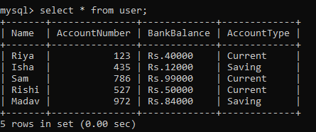

**Manager:**

**To create manager table:**

create table manager(ManagerName char(30),ManagerID int(40));



**To insert values into manager table:**

insert into manager values("Rohan",101),("Sonal",102),("Tom",103),("Varun",104),("Anu",105);



**To display the manager table:**

select * from manager;

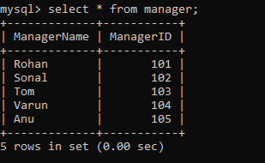

**Cashier:**

**To create cashier table:**

create table cashier(CashierName char(30),CashierID int(5));



**To insert values into cashier table:**

insert into cashier values("Manoj",201),("Teena",202),("Thara",203),("Karen",204),("Chan",205);



**To display the cashier table:**

select * from cashier;

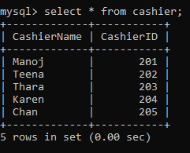

**Connectivity:**

With the help of My SQL.Net connector driver and My SQL for visual studio plugin/add-on, a connection between the front end (visual studio) and back end (My SQL databases) can be made successfully

To connect to the database, the following procedure are followed:

* Select TOOLS → Connect to Database
* Select a server name and the database name in the Add Connection dialog box.
* Click on the Test Connection button to check if the connection succeeded.
* Add a Data Grid View on the form.
* Click on the Choose Data Source combo box.
* Click on the Add Project Data Source link.
* This opens the Data Source Configuration Wizard.
* Select Database as the data source type.
* Choose Data Set as the database model.
* Choose the connection already set up.
* Save the connection string.
* Choose the database object, user table in our example, and click the Finish button.

**Front End:**

The Front End of this project was built on Visual Studio software using visual basic.

**Tool Used:**

* Form
* Group Box
* Label
* Button
* Text Box

**Home Page:**

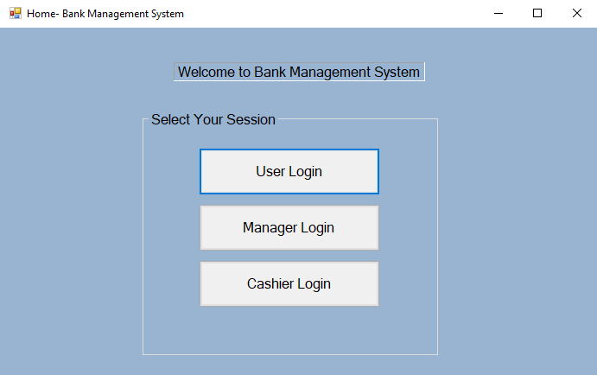

This is the Home Page of the Bank Management System which consists of group box, label and three login buttons. From these three, the person who has to login should select his/her session.

**User- Login Page:**

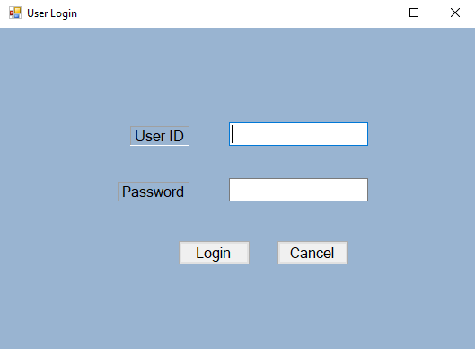

If the person chooses the user login, then it appears as the above. In this page there are two text boxes, one for user id and the other for password and two buttons are present below, one for login and the other for cancel. The user has to enter their correct user id and password in the provided text box, then click the login button to enter into his/her user page.

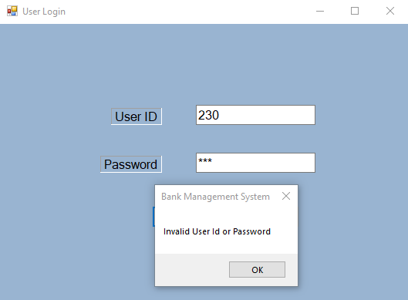

If the user provides the wrong user id or password, it will not allow to enter into his/her account.

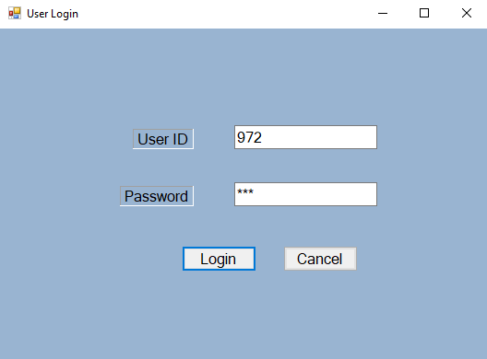

If the user provides the correct user id and password, it allows to enter into his/her account.

**User- Main Page:**

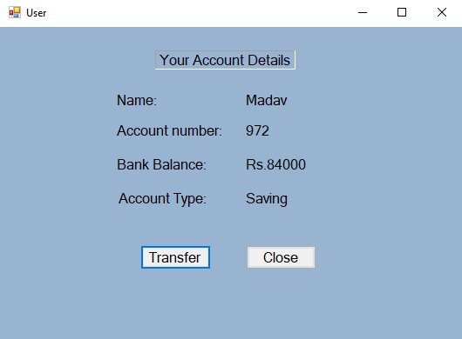

This is the user main page where the user’s account details will be displayed. It consists of labels and buttons. There are two buttons, one for fund transfer and the other for close. If the user wants to transfer the fund from his/her account to other user’s account, he/she has to click the transfer button.

**Fund Transfer Page:**

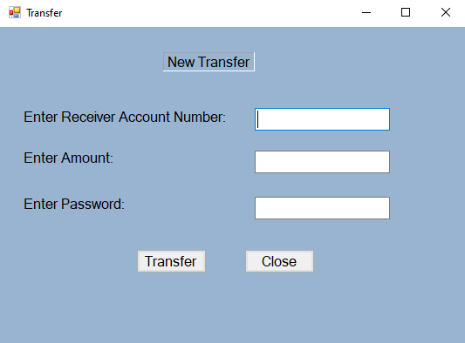

In this page there are two buttons for transfer and close and three text boxes where the user has to provide the receiver’s account number, the amount to be transferred and the user’s account password for confirmation, then click the transfer button to transfer the amount.

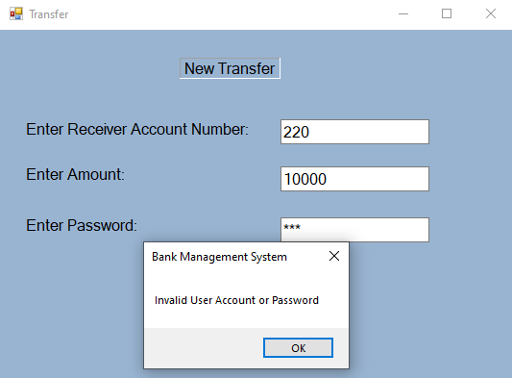

If the provided account number or password is incorrect, it will prompt that the given account number or password is invalid.

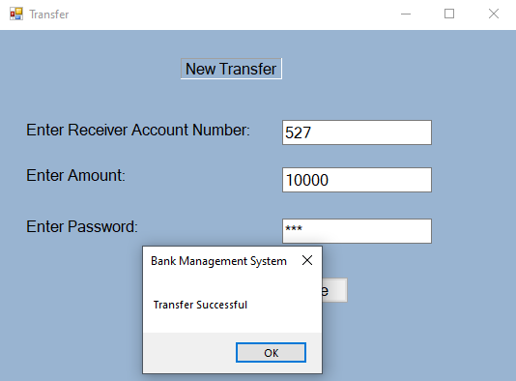

If the provided account number and password is correct, the fund will be successfully transferred to the receiver’s account.

**Manager- Login Page:**

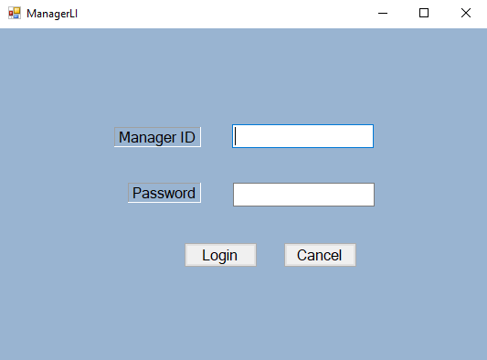

If the person chooses the manager login, then it appears as the above. In this page there are two text boxes, one for manager id and the other for password and two buttons are present below, one for login and the other for cancel. The manager has to enter their correct manager id and password in the provided text box, then click the login button to enter into his/her manager page.

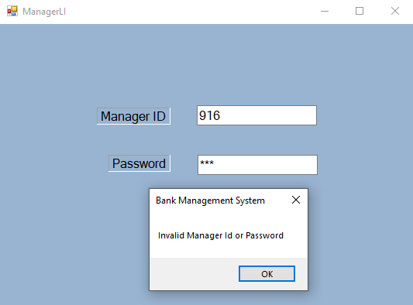

If the manager provides the wrong manager id or password, it will not allow to enter into his/her page.

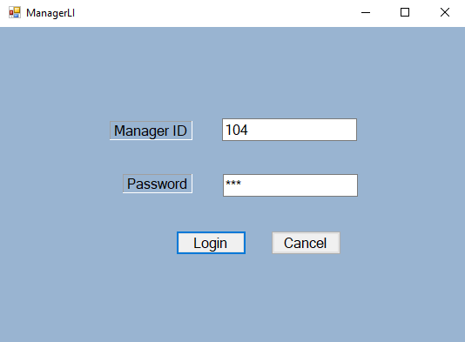

If the manager provides the correct manager id and password, it allows to enter into his/her page.

**Manager- Main Page:**

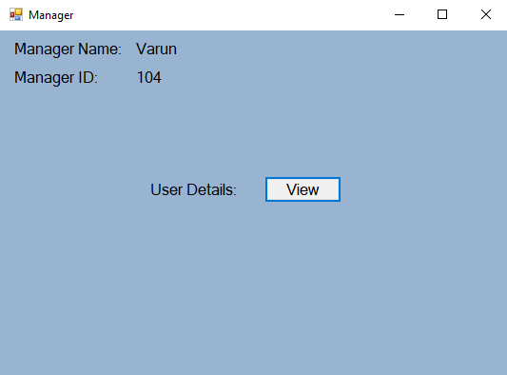

This is the manager main page where the manager details will be displayed. It consists of labels and a view button. By clicking on the view button, the manager will be allowed to enter into the next page where the user details will be displayed.

**View and Edit Page:**

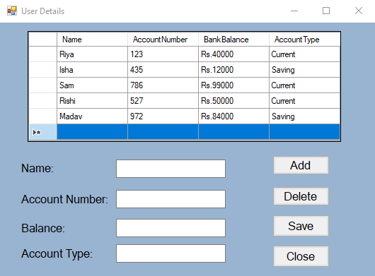

This is the page where the manager can view user details and edit. It consists of the labels, text boxes and four buttons- Add, Delete, Save, Close.

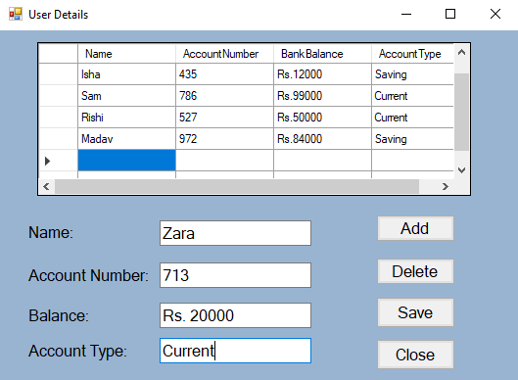

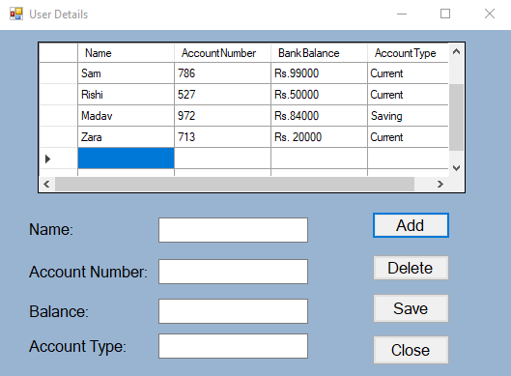

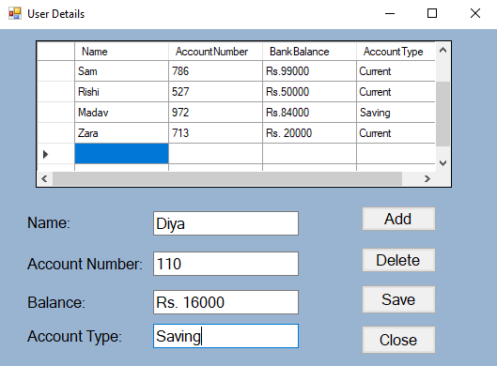

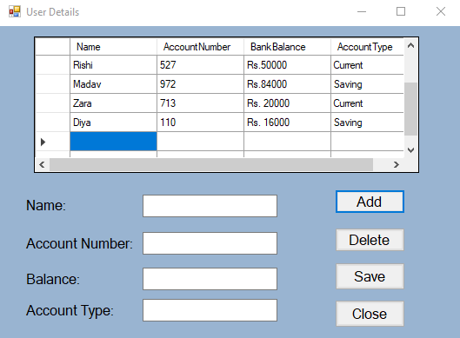

To add an account, the manager has to provide the user’s name, account number, balance and account type in the given text box and then click the add button. The account will be added into the database successfully.

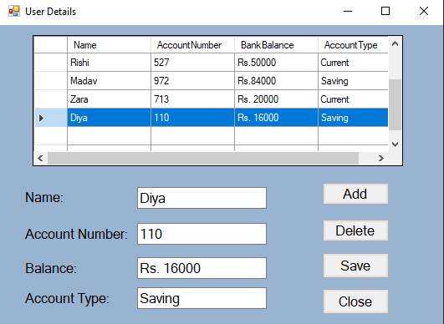

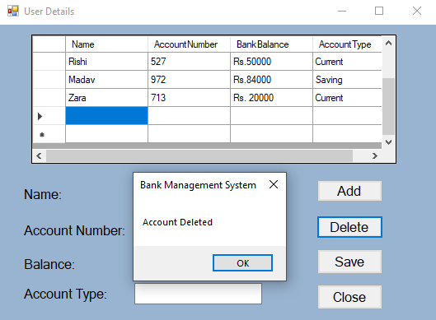

To delete an account, the manager has to select the account to be deleted and then click the delete button. The selected account will be deleted successfully from the database.

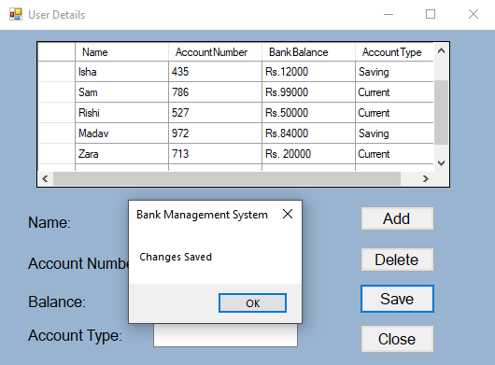

To save the changes, the manager has to click the save button. The changes will be saved successfully in the database.

**Cashier- Login Page:**

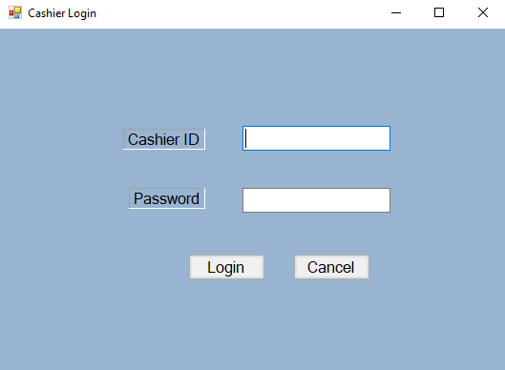

If the person chooses the cashier login, then it appears as the above. In this page there are two text boxes, one for cashier id and the other for password and two buttons are present below, one for login and the other for cancel. The cashier has to enter their correct cashier id and password in the provided text box, then click the login button to enter into his/her cashier page.

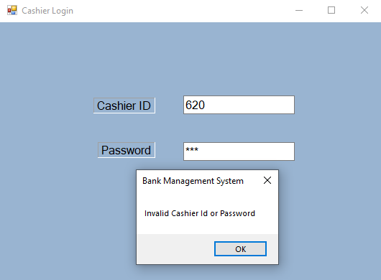

If the cashier provides the wrong cashier id or password, it will not allow to enter into his/her page.

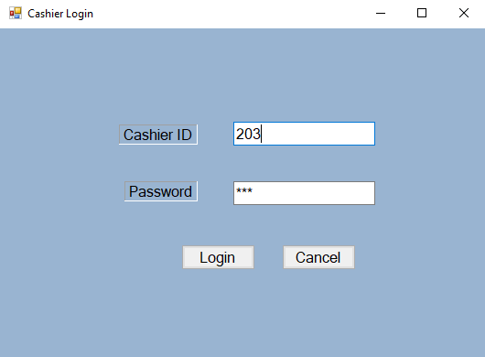

If the cashier provides the correct cashier id and password, it allows to enter into his/her page.

**Cashier- Main Page:**

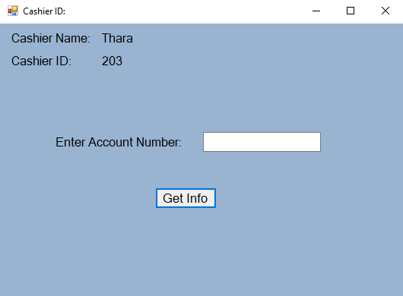

This is the cashier main page where the cashier details will be displayed. It consists of labels, get info button and a textbox where the cashier has to provide the required user account number.

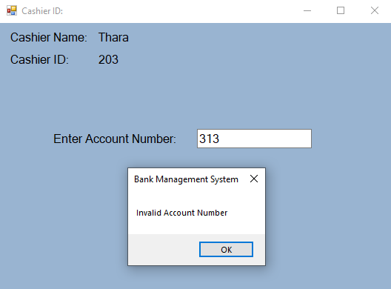

If the given account number is incorrect, it will prompt that the given account number is invalid.

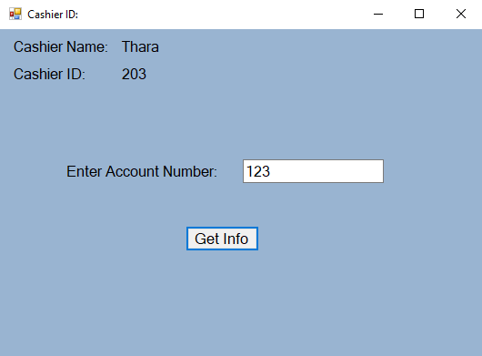

After providing the correct account number, click the get info button present at the bottom. By clicking on the get info button, the cashier will be allowed to enter into the next page where the user details will be displayed.

**Withdraw and Deposit Page:**

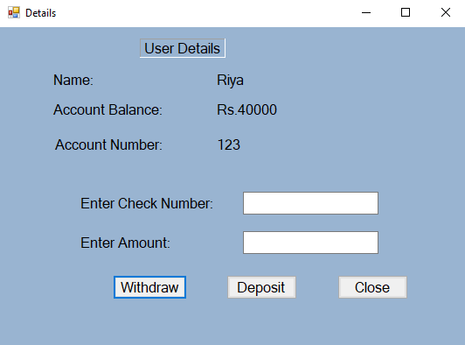

This is the page where the cashier can view user details, withdraw and deposit the amount. It consists of the labels, text boxes and three buttons for withdraw, deposit and close.

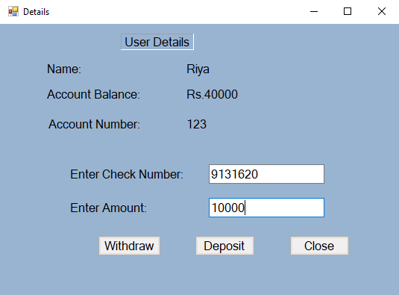

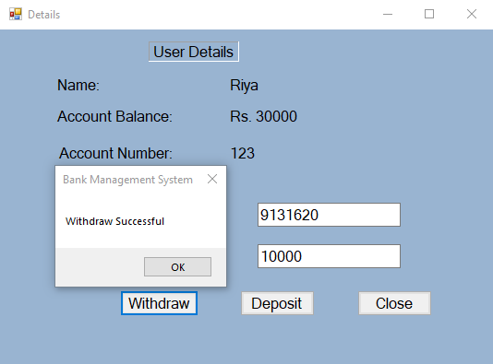

To withdraw the amount from the account, the cashier has to provide the check number and the amount to be withdraw in the given text box and then click the withdraw button. The amount will be withdrawn successfully from the account and will also display the balance amount in the user details.

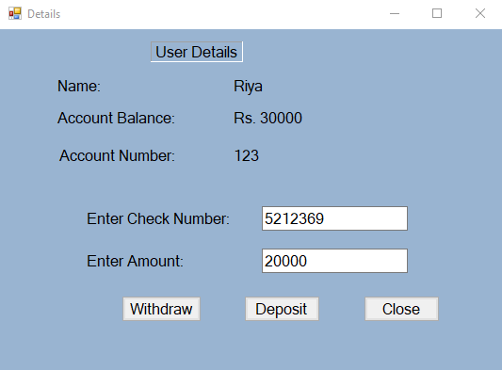

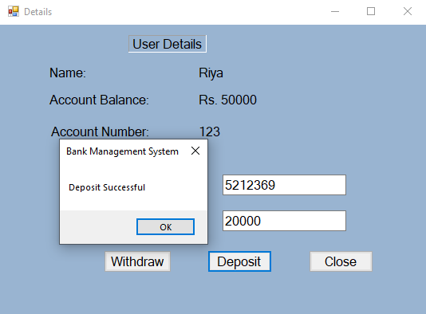

To deposit the amount into the account, the cashier has to provide the check number and the amount to be deposited in the given text box and then click the deposit button. The amount will be deposited successfully into the account and will also display the balance amount in the user details.

**Result:**

The Project “Bank Management System” has been completed successfully.

**Team Members:**

* **Syed Mateen Hussain- RA1811003040049**
* **M. Aishwarya- RA1811003040117**
* **Kurapati Vishnu Sai Reddy- RA1811003040174**
* **A. M. Kiruthik- RA1811003040178**